PSQL ASSIGNMENT -1

-- Create database if not exists

CREATE DATABASE IF NOT EXISTS university_db;

\c university_db;

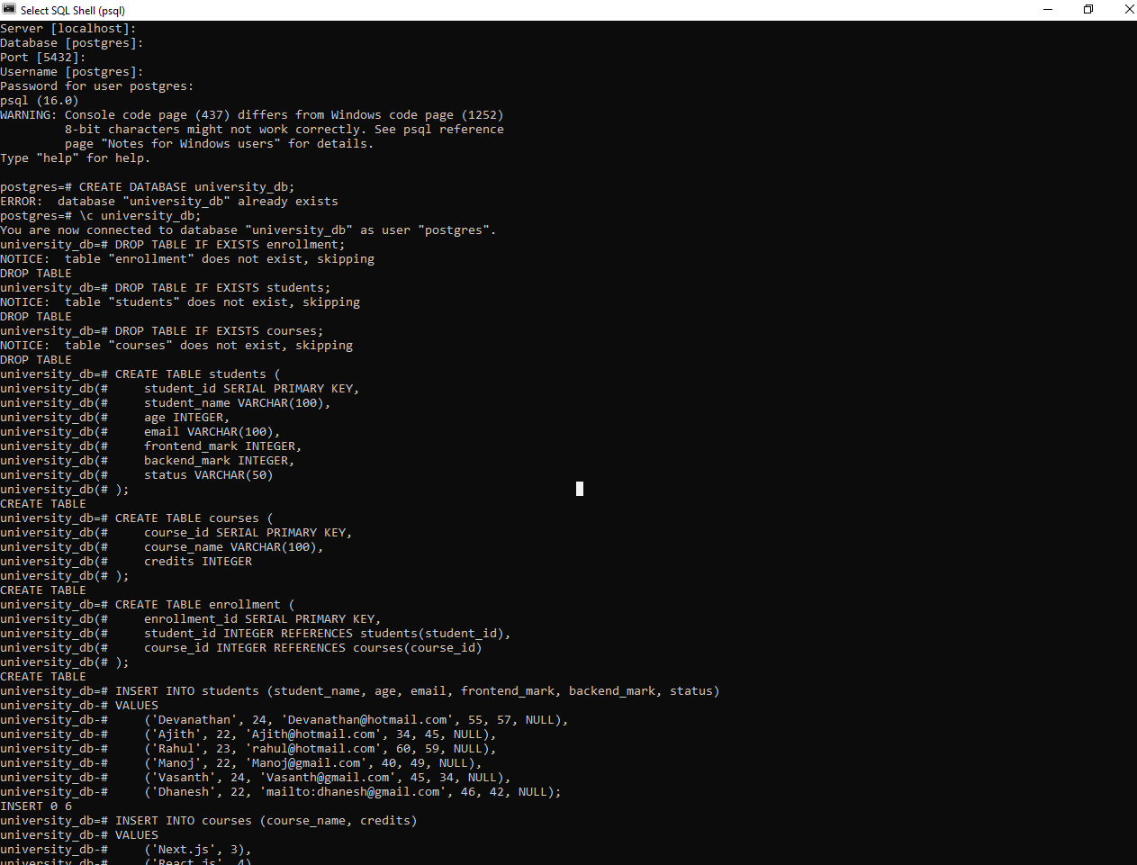

-- Drop tables if they exist to start fresh

DROP TABLE IF EXISTS enrollment;

DROP TABLE IF EXISTS students;

DROP TABLE IF EXISTS courses;

-- Create students table

CREATE TABLE students (

student_id SERIAL PRIMARY KEY,

student_name VARCHAR(100),

age INTEGER,

email VARCHAR(100),

frontend_mark INTEGER,

backend_mark INTEGER,

status VARCHAR(50)

);

-- Create courses table

CREATE TABLE courses (

course_id SERIAL PRIMARY KEY,

course_name VARCHAR(100),

credits INTEGER

);

-- Create enrollment table

CREATE TABLE enrollment (

enrollment_id SERIAL PRIMARY KEY,

student_id INTEGER REFERENCES students(student_id),

course_id INTEGER REFERENCES courses(course_id)

);

-- Insert sample data into students table

INSERT INTO students (student_name, age, email, frontend_mark, backend_mark, status)

VALUES

('Devanathan', 24, 'Devanathan@hotmail.com', 55, 57, NULL),

('Ajith', 22, 'Ajith@hotmail.com', 34, 45, NULL),

('Rahul', 23, 'rahul@hotmail.com', 60, 59, NULL),

('Manoj', 22, 'Manoj@gmail.com', 40, 49, NULL),

('Vasanth', 24, 'Vasanth@gmail.com', 45, 34, NULL),

('Dhanesh', 22, 'mailto:dhanesh@gmail.com', 46, 42, NULL);



-- Insert sample data into courses table

INSERT INTO courses (course_name, credits)

VALUES

('Next.js', 3),

('React.js', 4),

('Databases', 3),

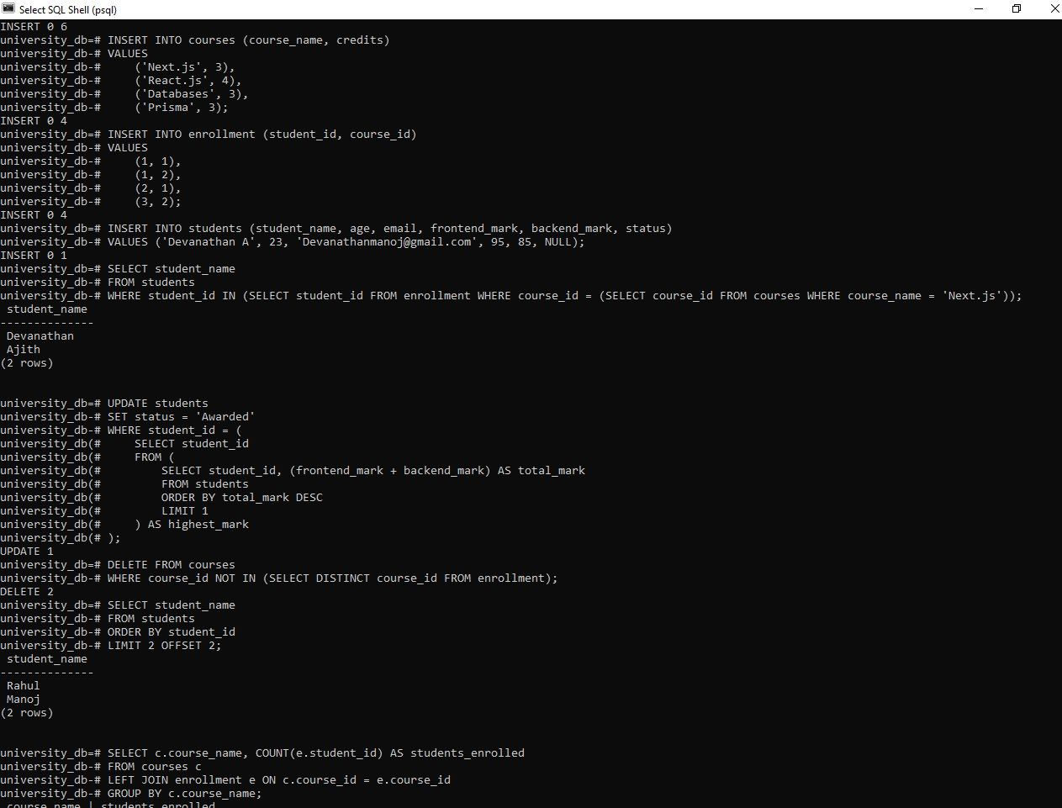 ('Prisma', 3);

-- Insert sample data into enrollment table

INSERT INTO enrollment (student_id, course_id)

VALUES

(1, 1),

(1, 2),

(2, 1),

 (3, 2);

-- Query 1: Insert a new student record

-- Replace with your actual details

INSERT INTO students (student_name, age, email, frontend_mark, backend_mark, status)

VALUES ('Devanathan A', 23, 'Devanathanmanoj@gmail.com', 95, 85, NULL);

-- Query 2: Retrieve names of students enrolled in 'Next.js'

SELECT student_name

FROM students

WHERE student_id IN (SELECT student_id FROM enrollment WHERE course_id = (SELECT course_id FROM courses WHERE course_name = 'Next.js'));



-- Query 3: Update status of student with highest total mark to 'Awarded'

UPDATE students

SET status = 'Awarded'

WHERE student_id = (

SELECT student_id

FROM (

SELECT student_id, (frontend_mark + backend_mark) AS total_mark

FROM students

ORDER BY total_mark DESC

LIMIT 1

 ) AS highest_mark

);

-- Query 4: Delete all courses that have no students enrolled

DELETE FROM courses

WHERE course_id NOT IN (SELECT DISTINCT course_id FROM enrollment);



-- Query 5: Retrieve names of students using LIMIT and OFFSET

SELECT student_name

FROM students

ORDER BY student_id

LIMIT 2 OFFSET 2;

-- Query 6: Retrieve course names and number of students enrolled in each course

SELECT c.course_name, COUNT(e.student_id) AS students_enrolled

FROM courses c

LEFT JOIN enrollment e ON c.course_id = e.course_id

GROUP BY c.course_name;

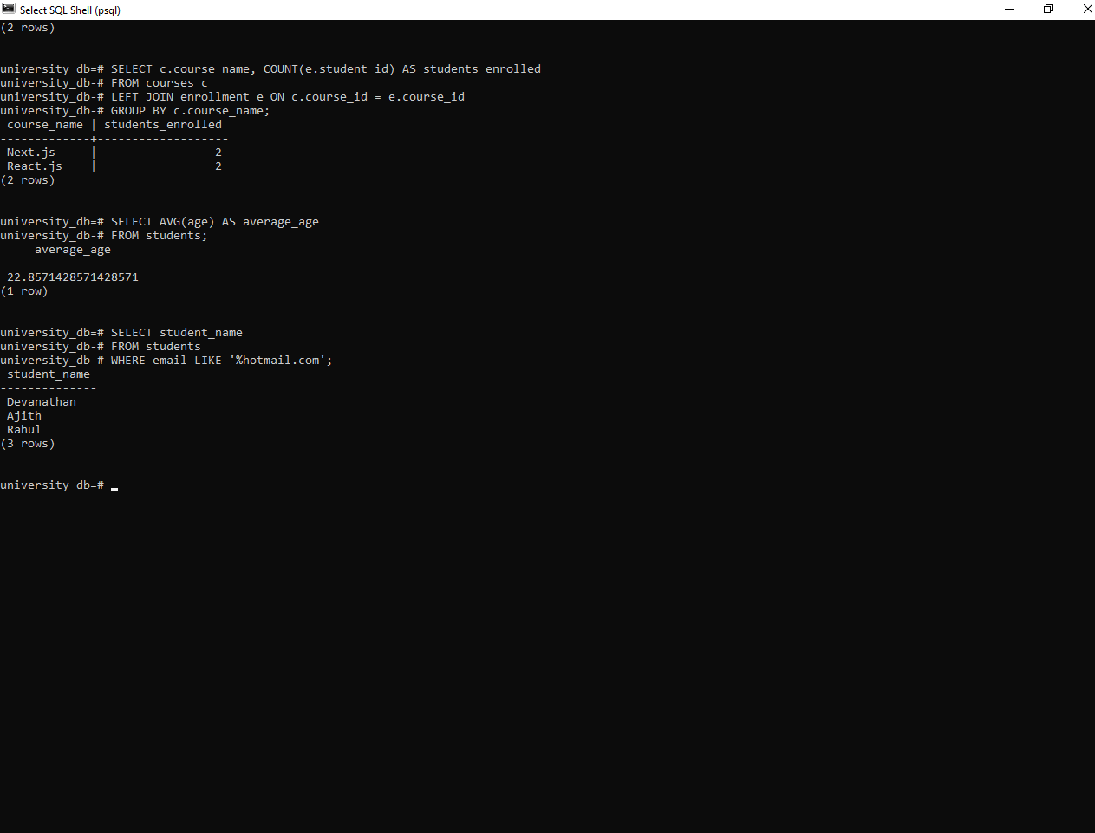

-- Query 7: Calculate and display average age of all students

SELECT AVG(age) AS average_age

FROM students;

-- Query 8: Retrieve names of students whose email addresses contain 'hotmail.com'

SELECT student_name

FROM students

WHERE email LIKE '%hotmail.com';